Melissa Lawrence, CSD 310, Assignment 5.2, 4-14-2024

**Three Screen Shots and reasons:**

**1)** This could be helpful for companies that use a week’s numbers for various reasons. I have worked for two large companies that use the week number (1-52) to schedule or request vacation. Others like my husbands used week numbers for the pay schedule.

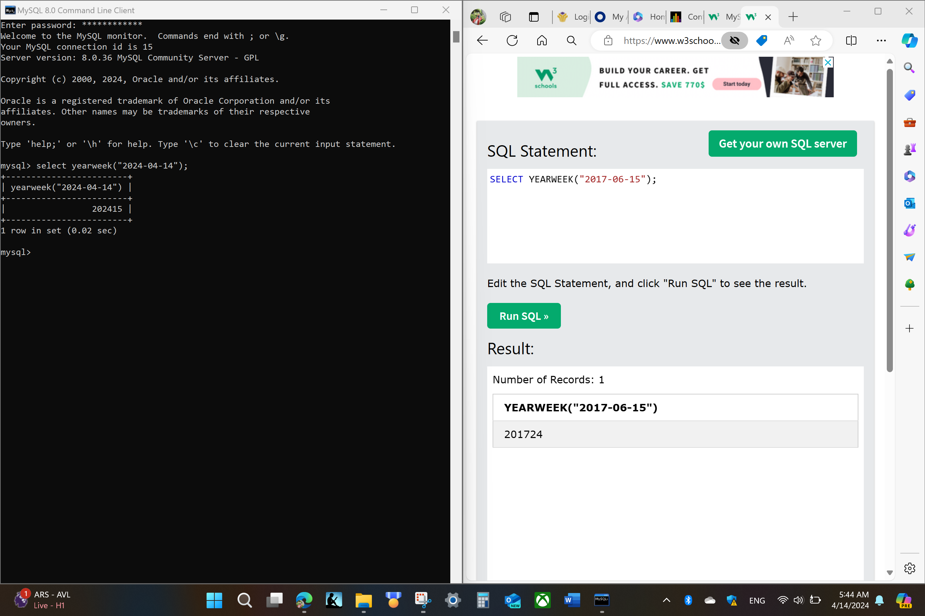

**2)** Time stamps can be important to document time for various reasons. Examples: 1) record time start and stop working, for billing; 2) If there is a cut off for data collection a user can time stamp the final collect time; and 3) Micromanager boss wants to micromanage your time so you time stamp everything to cover yourself?

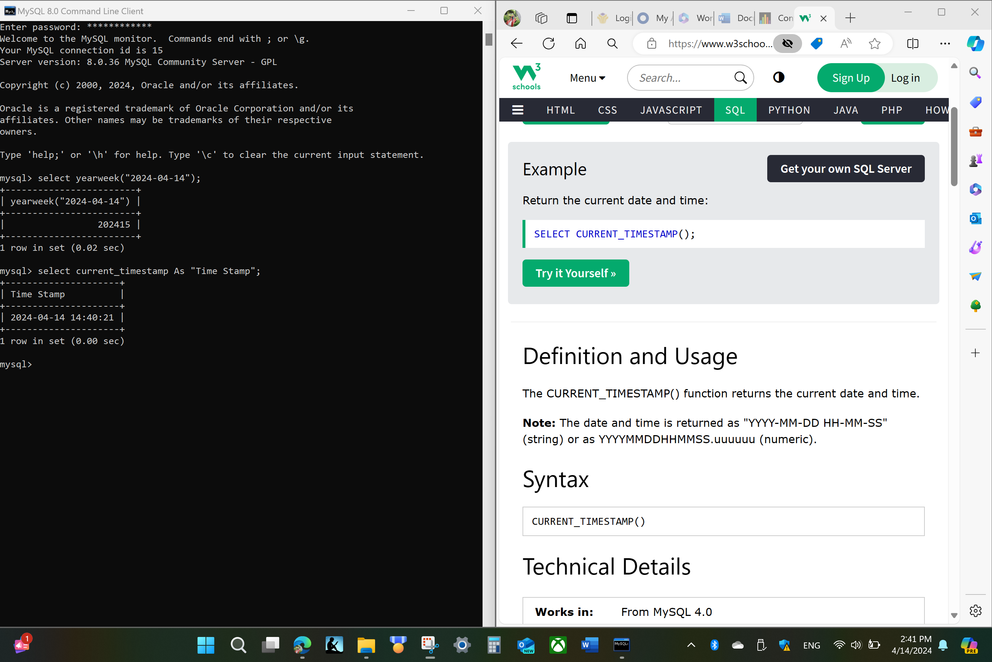

**3)** This is the most important command because you can find out how many days until Christmas! Or whatever date is important to you or a project deadline.

